//Assignment 15.2

1. Explain the working and the differences between Maven, Gradle and SBT in detail.

Ans –

Maven is a, it is for defining how .java files get exported to .jar files. It is highly independent development tool which downloads necessary additional tools or scripts by incorporating other common tasks like downloading & installing necessary libraries etc. It is built portability theme so that the problems of code executing in one machine and not in the other is solved by using this development tool. Because of this, it is also the best way to work on a project between people who use different IDEs since IDE-generated Ant scripts are hard to import into other IDEs, but all IDEs nowadays understand and support Maven ([IntelliJ](http://www.jetbrains.com/idea/features/ant_maven.html), [Eclipse](http://www.eclipse.org/m2e/), and [NetBeans](http://wiki.netbeans.org/Maven)).

1. Maven will download all the libraries that you use and the libraries that they use for you automatically
2. You don't need to write a "compile", "test", "package", or "clean" step like you would have to do in Ant or a Makefile.

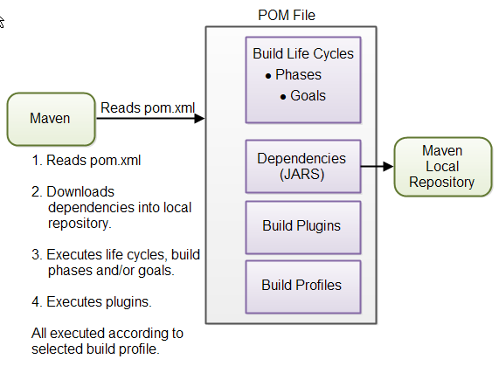

Gradle

1. Gradle is an advanced general purpose build management system. Gradle supports the automatic download and configuration of dependencies or other libraries. It supports Maven repositories for retrieving its dependencies. This allows reusing the artifacts of existing build systems.
2. Declarative builds and build-by-convention- Gradle is available with separate Domain Specific Language. Gradle provides declarative language elements.
3. The declarative language lies on top of a general purpose task graph, which you can fully leverage in your build.
4. It allows to build the optimized structure which can be easily built.
5. Using Deep api and customize its configuration and execution behavior to its core.
6. If you build a subproject, Gradle takes care of building all the subprojects that it depends on.
7. It has different ways to manage the dependencies
8. It has different ways to manage the builds.
9. Gradle supports all the functions of Maven and ANT. It also provides a converter for turning a Maven pom.xml to Gradle script. 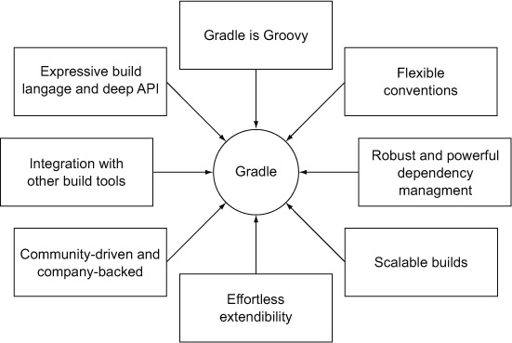

SBT

1. sbt is an [open source](https://en.wikipedia.org/wiki/Open_source) [build tool](https://en.wikipedia.org/wiki/Build_tool) for [Scala](https://en.wikipedia.org/wiki/Scala_(programming_language)) and [Java](https://en.wikipedia.org/wiki/Java_(programming_language)) projects.
2. SBT can consume and produce maven artifacts, so you can migrate incrementally .
3. SBT build configurations are less verbose than the equivalent POM files, and they are written in Scala code, so you can express whatever you need to get build your project, for example triggering code   
   generation. SBT console mode keeps scala resident, which really improves compile times on subsequent runs. This is important for scala, which is quite slow as compared to javac.